# **Observation Station:** **Tumble Buggy**

[1]

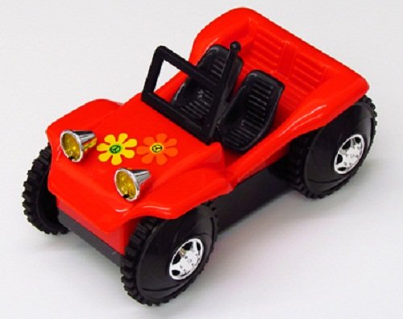

Directions:

* Using the switch on the bottom of the buggy, turn the buggy on.
* Place the buggy on the floor.
* Make observations.
* Turn the buggy off.

# **Observation Station: Wind-Up Toys**

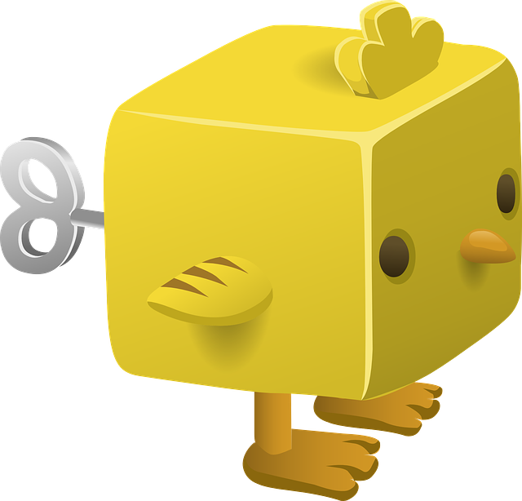**[2]**

Directions:

* Using the winding dial, gently wind the toy. Be gentle. It only takes a few twists.
* Place the toy on the table and release the toy.
* Make observations.

**Observation Station: Air Puck**

**[3]**

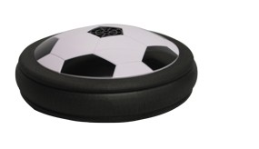

Directions:

* Using the switch underneath the Air Puck, turn the Puck on and place it on the floor.
* Make observations.
* Give the Air Puck a gentle push with your hand.
* Make observations.

**Observation Station: Ball Drop**

**(goggles required)**

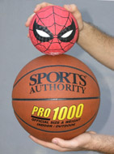

[4]

Directions:

* Drop the smaller ball from chest height.
* Make observations.
* Drop the bigger ball from chest height.
* Make observations.
* Now stack the smaller ball on top of the bigger ball. Release the balls at the same time so that they fall together.
* Make observations.

**Observation Station: Carts on a Track**

# ***(*be sure to keep the carts on the tracks or table at all times, prevent them from falling off the table!!!)***

**[5]**

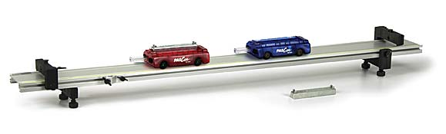

Directions:

* Place one cart on the track and give it a gentle push.
* Make observations.
* Place both carts on the track, so that each is about 20 cm from the end stop. Give one cart a gentle push toward the other.
* Make observations.
* Raise on end of the track. Place a cart on the lower end of the track. Give the cart a gentle push up the ramp.
* Make observations.

**Observation Station: Watching Ice Melt**

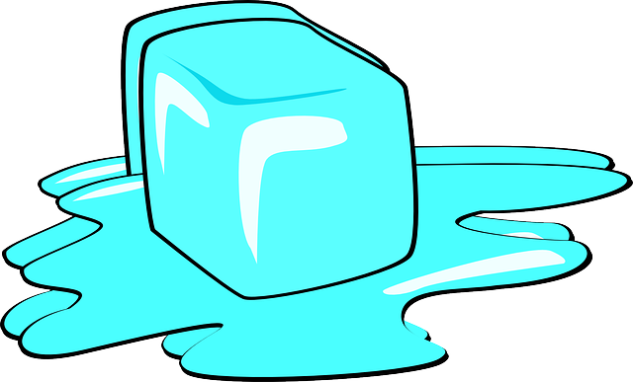**[6]**

Directions:

* Place one piece of ice on each of the two blocks.
* Make observations.

**Observation Station: Glow Sticks**

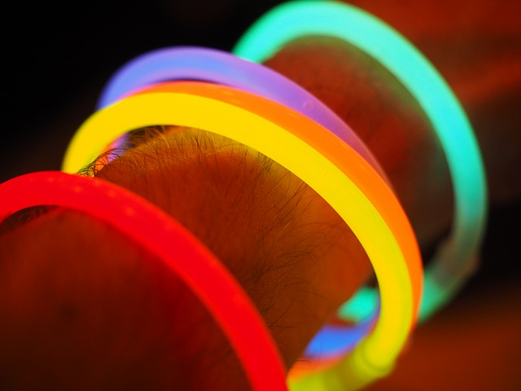**[7]**

Directions:

* Take one glow stick out of the package. Gently bend the glow stick until you hear a plastic “cracking” sound.
* Shake the glow stick until it glows.
* Make observations.

**Observation Station: Cheetos on Fire**

# (**goggles required**, one trial per group).

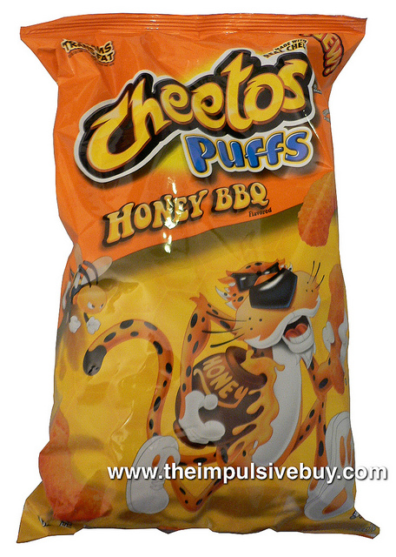**[8]**

Directions:

* Place one piece of Cheeto into an aluminum pie pan.
* Using the lighter wand, attempt to ignite the Cheeto. You may find it easier by maneuvering the flame to an internal surface of the Cheeto.
* Once the Cheeto is ignited, remove the lighter.
* Make observations

**Observation Station: Tuning Fork**

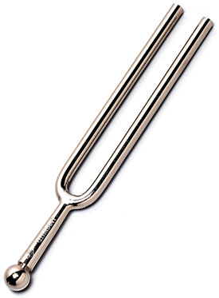**[9]**

Directions:

* Grasp the single end of the tuning fork. Tap the open end of the tuning fork with the rubber mallet or against the palm of your hand.
* Make observations.
* Repeat striking the tuning fork with the mallet or palm, and this time place the open end of the fork so that it just touches the surface of the water in the shallow dish.
* Make observations.

**Observation Station: Airzooka**

**[10]**

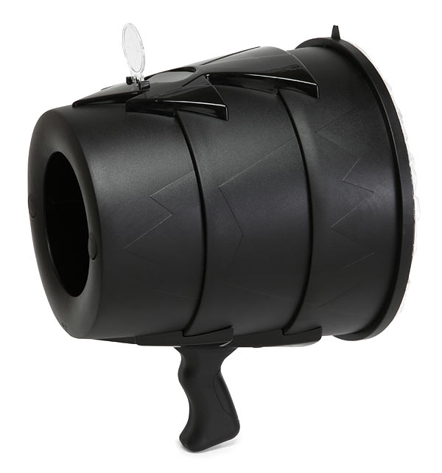

Directions:

* Hold the Airzooka handle in one hand, and pull back the elastic air launcher nob with the other.
* Aim the Airzooka at the suspended piece of paper and release the air launcher.
* Make observations.

**Teacher’s Note:**

**The following pages contain pages for other stations you can use in the Unit 1 Observation Stations Lab. The last page is a blank template you can use to create pages for your own stations.**

# **Observation Station: Pop, Pop, Fizz, Fizz, . . .**

# (**goggles required**, one trial per group).

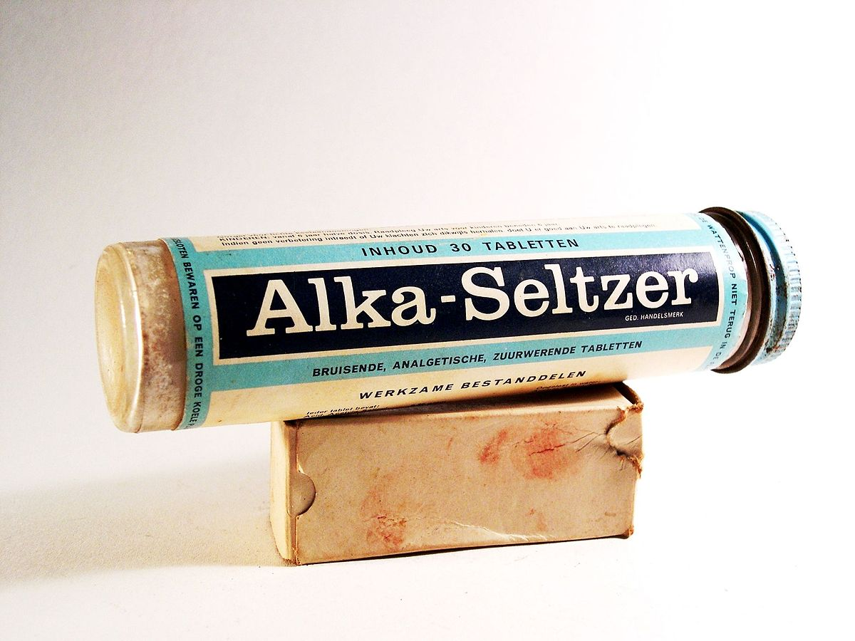**[11]**

Directions: *Please read all directions before beginning*.

* Place ½ tablet of Alka Seltzer in film canister.
* Have the film canister cap ready. Pour 1 test tube of water into the film canister and quickly replace the cap.
* Quickly place the closed film canister, lid side down, into the clear jar. You need to move quickly on this one.
* Stay clear of the canister opening! Please view from the *side*!
* Make observations.

**Observation Station: Rubbing Hands**

**[12]**



Directions:

* With your palms together, compress your palms and fingers.
* Rub your hands, alternating forward and backward for several seconds.
* Place your hands on your cheeks.
* Make observations.

# **Observation Station: Popper Toy**

**[13]**

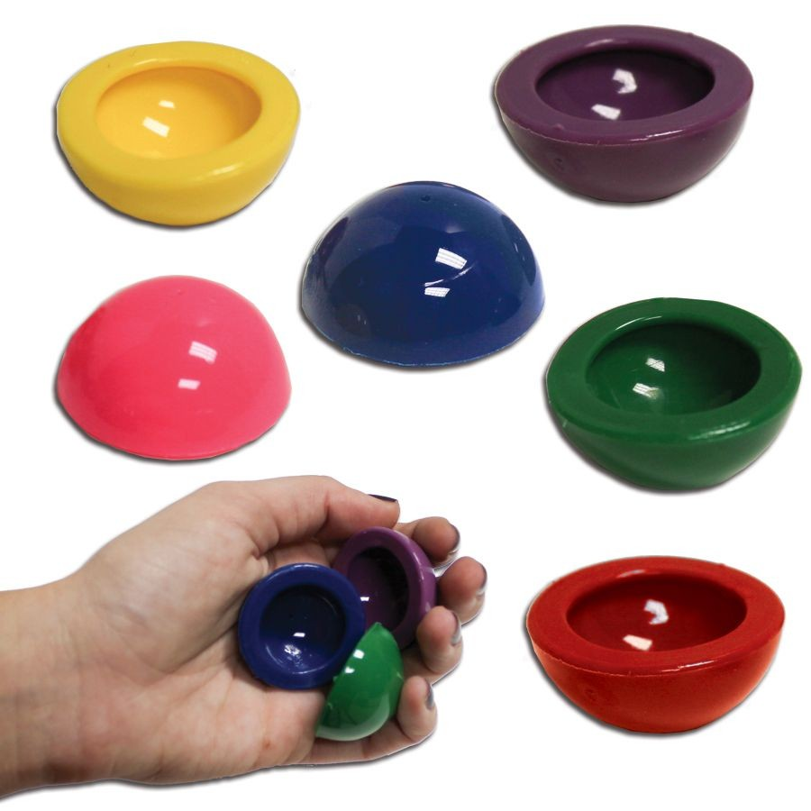

Directions:

* Turn the popper inside out and quick place it on the table.
* Release and watch.
* Make observations.

# **Observation Station: Nose Crusher**

**[14]**

Directions: *Please read all directions before beginning*.

* Pull the bowling ball up to your **nose** with the cable taut (tight).
* Release the ball, allowing it to swing smoothly away from your nose (Note is very important to “let go” the ball and NOT to push the ball in any way.)
* **Sit (or stand) still** as the ball swings away from you and then back towards you. DO NOT MOVE.
* Make observations.

# **Observation Station: [Insert Station Title Here]**

**[Insert Image Here and cite image source in the footnote][15]**

Directions:

* [Insert appropriate directions here]
* Make observations.

1. Image Source: <http://underscoopfire.com/wp-content/uploads/2014/03/tumble-buggy.jpg>
2. Public Domain [CC-0 <https://pixabay.com/en/toy-animal-yellow-wind-up-eyes-576488/> ]
3. <http://www.arborsci.com/air-powered-puck?gclid=CIjav5v1vtMCFQsuaQodYfkNfg>
4. <http://sirius.ucsc.edu/demoweb/mechan/collis.php>
5. <http://demoweb.physics.ucla.edu/content/10-dynamics-track-demos>
6. Public Domain [CC-0 <https://pixabay.com/en/ice-cube-melting-ice-frozen-295036/> ]
7. Public Domain [CC-0 <https://pixabay.com/en/glow-stick-colorful-light-color-693843/> ]
8. <https://www.flickr.com/photos/theimpulsivebuy/5878178681>
9. By Helihark - Own work, CC BY-SA 3.0, <https://commons.wikimedia.org/w/index.php?curid=18686251>
10. <http://www.thinkgeek.com/product/60b6/>
11. By Henk Albert de Klerk - Own work, CC BY-SA 4.0, <https://commons.wikimedia.org/w/index.php?curid=36708118>
12. <http://www.thinkgeek.com/product/60b6/>
13. <https://www.windycitynovelties.com/rubber-1-1-2-poppers-12-pack.html?gclid=CK37xc-Bv9MCFQSQaQodLP8AVQ>
14. <http://www.ap.smu.ca/pr/sarty-t-and-o/outreach>
15. <http://www.thinkgeek.com/product/60b6/>